Dataset
create database e_commerce_retail;

use e_commerce_retail;

CREATE TABLE customers (
customer_id VARCHAR(10) PRIMARY KEY,
customer_name VARCHAR(50),
gender VARCHAR(5),
signup_date DATE,
city VARCHAR(30)
);

CREATE TABLE products (
product_id VARCHAR(10) PRIMARY KEY,
product_name VARCHAR(50),
category VARCHAR(30),
cost_price DECIMAL(10,2)
);

CREATE TABLE orders (
order_id VARCHAR(10) PRIMARY KEY,
customer_id VARCHAR(10),
order_date DATE,
order_status VARCHAR(20),
total_amount DECIMAL(10,2),
FOREIGN KEY (customer_id) REFERENCES customers(customer_id)
);

CREATE TABLE order_items (
item_id VARCHAR(10) PRIMARY KEY,
order_id VARCHAR(10),
product_id VARCHAR(10),
quantity INT,
price DECIMAL(10,2),
FOREIGN KEY (order_id) REFERENCES orders(order_id),
FOREIGN KEY (product_id) REFERENCES products(product_id)
);

Analysis

1. Monthly Revenue Trend + Running Total

How does revenue change month-over-month, and what is the cumulative revenue?
with cte as(select year(order_date) as years, month(order_date) as months, sum(total_amount) as revenue
from orders where order_status="Delivered" group by years, months),

trend as (select years, months, revenue, lag(revenue) over (order by years, months) as prev_rev,
sum(revenue) over(order by years, months) as cum_rev
from cte)

select years, months, revenue, round((revenue-prev_rev)/prev_rev,2) as MOM_Change, cum_rev from trend;

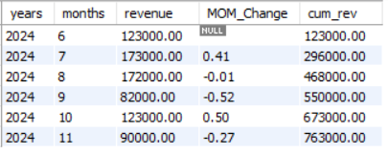
2. Top 3 Products Per Category (Window Function)

Which are the top 3 revenue-generating products in each category?

with cte as (select prd.category as categories, prd.product_name as products, sum((orditm.quantity*orditm.price)) as total_value
from products prd join order_items orditm on prd.product_id = orditm.product_id
join orders ord on ord.order_id = orditm.order_id where order_status = "Delivered"
group by categories, products),

top_products as (select categories, products, total_value,
dense_rank() over (partition by categories order by total_value desc) as ranks from cte)

select categories, products, total_value from top_products where ranks<=3;

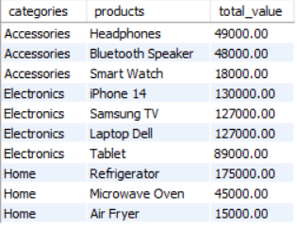

3. Customer Lifetime Value Ranking

Rank customers based on total lifetime spend.
select cust.customer_id customer_id, cust.customer_name customer_names, sum(ord.total_amount) as total_spend,
rank() over (order by sum(ord.total_amount) desc) as ranks
from customers cust
join orders ord on cust.customer_id = ord.customer_id
where order_status="Delivered"
group by cust.customer_id, cust.customer_name order by ranks;

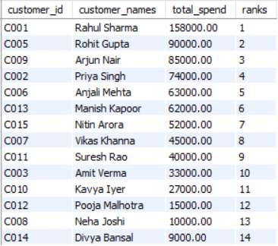

4. Customer Segmentation (High / Medium / Low)

Segment customers based on total spend.
select ord.customer_id, cust.customer_name, sum(total_amount) as Total_Value,
case
when sum(total_amount)>50000 then "High Value"
when sum(total_amount)>20000 and sum(total_amount)<50000 then "Medium Value"
when sum(total_amount)<20000 then "Low Value"
else "No value"
End as Segment
from customers cust
join orders ord on cust.customer_id = ord.customer_id group by ord.customer_id;
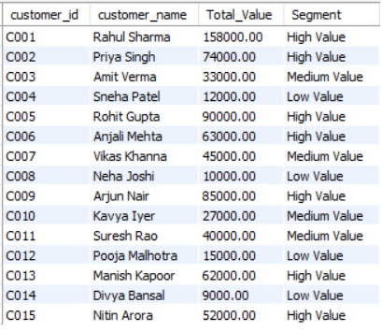

5. Churn Detection

Identify customers inactive for 90+ days.
select cust.customer_id, MAX(ord.order_date) as last_order_date from customers cust
join orders ord on cust.customer_id = ord.customer_id
group by cust.customer_id having DATEDIFF(CURDATE(), max(ord.order_date))>90;

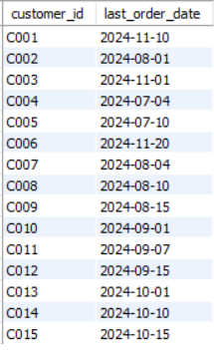

6. Repeat Customer Percentage

What percentage of customers are repeat buyers?

with cte as (select cust.customer_id, count(ord.order_id) as num_orders from customers cust join
orders ord on cust.customer_id = ord.customer_id group by cust.customer_id having num_orders>1)

select round((select count(*) from cte)*100/(select count(distinct(customer_id)) from orders),2) as repeat_cust_percent;

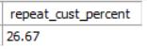

7. Product Profitability Analysis

Which products generate the highest profit?

select prd.product_id, prd.product_name, sum(ord_itm.quantity * ord_itm.price)-sum(ord_itm.quantity * prd.cost_price) as profit
from products prd join order_items ord_itm on prd.product_id = ord_itm.product_id
join orders ord on ord_itm.order_id = ord.order_id where order_status="Delivered"
group by prd.product_id, prd.product_name order by profit desc;

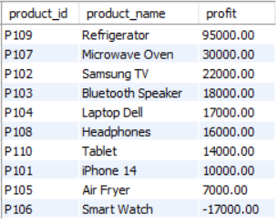

8. City Revenue Contribution %

Which cities contribute most to revenue?

select cust.city, sum(ord.total_amount) as total_contributions,
concat(round(sum(ord.total_amount)/(select sum(total_amount) from orders)*100,2),"%") as contributions
from customers cust join orders ord
on cust.customer_id = ord.customer_id where order_status = "Delivered" group by cust.city
order by total_contributions desc limit 5;

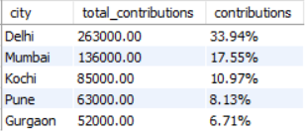

9. Average Order Value by Customer Segment

What is the average order value across High / Medium / Low segments?

with customer_segments as (select cust.customer_id, round(sum(ord.total_amount),2) as total_order_amount,
Case
when sum(ord.total_amount)<=15000 then "Low Segment"
when sum(ord.total_amount)<=40000 then "Medium Segment"
when sum(ord.total_amount)>40000 then "High Segment"
else "Wrong Amount"
end as customer_segment
from customers cust
join orders ord on cust.customer_id = ord.customer_id where ord.order_status="Delivered" group by cust.customer_id)

select cs.customer_segment, round(avg(ord.total_amount),2) as avg_order_val from customer_segments cs
join orders ord on ord.customer_id = cs.customer_id
group by cs.customer_segment
order by avg_order_val desc;

